**Department of Information Technology,**

**Rajarambapu Institute of technology,**

**Rajaramnagar**

**System Design On**

**‘Vehicle security system using IOT’**



**Under Guidance Of**

MR. Ravindra Mandle

**Prepared by-**

Sayali Jadhav(1604017)

Dhanashri Patil(1604002)

Pranita Patil(1604005)

Prajakta Tarlekar(1604008)

Rucha Kulkarni(1604010)

**Table of Contents**

1 Introduction 4

1.1 Purpose 4

1.2 Scope 4

1.3 Definitions, Acronyms, and Abbreviations. 5

1.4 Overview 5

2 The Overall Description 5

2.1 Product Perspective 5

2.1.1 Hardware Interfaces 5

2.1.2 Software Interfaces 5

2.2 Product Functions 5

2.3 User Characteristics 6

2.4 Apportioning of Requirements. 6

2.5 Assumptions and Dependencies 6

3 Specific Requirements 7

3.1 External Interfaces 7

3.1.1 User Interfaces 7

3.1.2 Software Interfaces 7

3.1.3 Hardware Interfaces 7

3.1.4 Communication Interfaces 8

3.2 Functional Requirements 8

3.3 Nonfunctional Requirements 100

3.3.1 Performance Requirements 100

3.3.2 Logical Database Requirements 100

3.3.3 Design Constraints 111

3.3.4 Standards Compliance 111

3.3.5 Reliability 111

3.3.6 Availability 111

3.3.7 Security 111

3.3.8 Maintainability 11

3.3.9 Portability 111

4

Change Management Process 122

5 Document Approvals 122

5.1 Team One Approval 122

5.2 Team Two Approval 122

6 Supporting Information 122

1. **Introduction:**

IOT is the network of physical object or things and has vast applications in all domains. Vehicle security is a most sensitive problem faced by people. The safety of vehicle is extremely essential for public vehicles. Most of the population in India buy the new vehicle but they fail to secure their vehicle. So, we are designing the device that help to secure your vehicle from vehicle theft, vehicle part theft, vehicle fire and other action. This device gives the protection to vehicle, user don’t need to worry about vehicle. Vehicle tracking and security system can be installed in vehicle to track place of vehicle.

Just using mobile you can find the location of your vehicle. It give the ring/message on your mobile when your vehicle’s surrounded area will overheated. Our device give the alert message, when risk to your vehicle.

**1.1 Purpose:**

* To detect fire early so as to initiate prevention.
* To send alert notification to the vehicle owner.
* Provide protection from removal of accessories.

**1.2 Scope:**

The main objective of VSS is to provide security to the vehicle owner from theft or fire activity which is happen inside or outside parking. Our goal is to develop the system that are improves the safety of the user.

More specifically, this system will be present in the vehicle which is present in the parking and will also search for the location of both vehicle and the user. Once we get the location of user we can send the notification or message to the user by using GPS and GSM module. Finally we will disengage from controlling various theft or fire activities.

**1.3 Definitions, acronyms, and abbreviations:**

Definitions:

* User - Owner of the vehicle who uses this system.
* Sensors - Motion sensor are used to detect the motion of any part of vehicle and flame sensor is used to sense fire activity.

Acronyms:

* VSS - Vehicle Security System
* GPS - Global Positioning System
* GSM - Global System for Mobile Communication.

**1.4 Overview:**

Our project Vehicle Security System (VSS) aims to prevent vehicle from theft as well as fire activity. It includes sensors to detect fire and the motion of any part of the vehicle. Also it includes GPS and GSM module to track the location of vehicle. And send the message to user. Once user will get the notification then he can take quick action about fire or theft.

**2. The Overall Description**

This IOT based project aims to prevent vehicle from fire or theft. This covers the function and constraints of the VSS. It provides context for the system and presents goals of its functionality.

**2.1 Product Perspective**

Vehicle security system (VSS) is a component of a general security system. It contributes to the protection of any bike at the parking system. This security system is used and managed by vehicle owner to recognize and identify the any theft or fire activity.

The system consists of Arduino, GPS & GSM module, sensors and Android phone. In which GPS is used for track the location and fire sensor and motion sensor detect the any fire or theft activity .After detection process, it gives alert message to the owner’s android device.

**2.1.1 Hardware Interfaces**

Hardware device which is wearable component consists the Arduino, sensors, android phone, GPS and GSM module.

Arduino Uno board is a microcontroller based on the ATmega328. The flame sensor and motion sensor to detect fire and theft activity. The Jumper wire establishes an electrical connection between these components. GPS uses satellites to track the position of any object with a GPS tracking chip. GSM is globally accepted standard for digital cellular communications. Android phone uses as to get the alert notification to maintain security purpose.

**2.1.2 Software Interfaces**

The software requirements in this security system are Arduino IDE, Android studio.

The Arduino IDE is a cross-platform application for windows, Linux etc. This is implemented programming language java. It is used to write and upload programs to Arduino board. Android studio is the IDE for mobile application development.

**2.2 Product Functions**

The existing Vehicle Security System (VSS) is for preventing vehicle from theft or fire. So we are designing the device that helps to secure your vehicle from theft or fire. Any theft or fire activity results in loss of private property. This loss can be minimized by applying vehicle security system.

This IOT based project aims to prevent vehicle from fire or theft. The system consists of Arduino, GPS, GSM, sensors and Android phone. GPS is used for vehicle tracking. Fire detector sensor allowing flame detection.

Just using android phone you can get the location of your vehicle. It gives the message on your phone, when vehicle is at risk.

**2.3 User Characteristics**

The user of the system is expected to have proper facilities to protect the vehicle.

They should also be introduced and familiar with the tracking system and alert notification to operate a security system.

This system used for companies, school, colleges and industries also used for public places to improve security.

**2.4 Apportioning of Requirements**

This project, we present a solution on how to protect the vehicle with affordable cost. Here, we made an attempt to develop a system based on IOT technology. This system is divided as fire/theft detection, security detection. The system also acquainted with GPS and GSM module to find vehicle location and communicate through cellular network .With this system, when someone is trying to steal the vehicle, it alerts the vehicle owner.

**2.5 Assumptions and Dependencies**

We can secure our vehicle from theft or fire. But there are still some security gaps where these technology don’t prevent fire or theft, don’t assist to recover it and don’t allow user to know status of their vehicle. Thief can’t permit owner to communicate with vehicle online, even if owner is certain that his vehicle is stolen.

If someone trying to ignite the vehicle, it alerts the vehicle owner when owner is at nearest distance as well as far from vehicle. But only alarm it is not possible to alert vehicle owner. So in this case we can use GPS network to send message to owner on his phone

**3. Specific Requirements:**

* 1. **External Interface**
     1. **User Interface:**

**3.1.2 Software Interface:**

Following are the software used for the vehicle security system using IOT.

* **Arduino IDE 1.8.6:**

Arduino is an open-source platform used for building electronics projects. Arduino consists of both a physical programmable circuit board (often referred to as a microcontroller) and a piece of software, or IDE (Integrated Development Environment) that runs on your computer, used to write and upload computer code to the physical board.

* **Android Studio 3.3.1:**

Android studio is the official IDE for developing application exclusively for Android platform. It has a strong editor tool for developing creative user interface.

* **JDK 1.10:**

The Java Development Kit (JDK) is an implementation of either one of the Java Platform, Standard Edition, Java Platform, Enterprise Edition, or Java Platform, Micro Edition platforms released by Oracle Corporation in the form of a binary product aimed at Java developers on Solaris, Linux, macOS or Windows. The JDK includes a private JVM and a few other resources to finish the development of a Java Application

* **Android SDK 28:**

SDK Tools is a downloadable component for the Android SDK. It includes the complete set of development and debugging tools for the Android SDK.

* + 1. **Hardware Interface:**
* **Arduino UNO:**

The Arduino Uno board is a microcontroller based on the ATmega328. It has 14 digital input/ output pins in which 6 can be used as PWM output, an ICSP header , a USB connection, 6 analog inputs , a power jack and a reset button.

* **Flame sensor:**

A flame sensor sense a weak DC signal from the AC power sent to the igniters which via the phenomenon of flame rectification in which the polarity of power sent through a flame is rectified to DC, flame is a poor conductor so the signal is more amps 3 to 5 usually.

* **Jumper wire:**

The term Jumper wire simply refers to a conducting wire that establishes an electrical connection between two points in a circuit. you can use jumper wire to modify a circuit or to diagnose problem in a circuit.

* **Android phone:**

We get the notification of fire and theft activity on android phone so we use android phone in this project. we make an android application to get notification of fire and theft.

* **GPS:**

GPS uses satellites to track the position of any object with a GPS tracking chip, including vehicles, peoples and pets. It works regardless of whether conditions and provides real-time positional data.

* **GSM:**

GSM is a globally accepted standard for digital cellular communications. GSM uses narrow board Time Division Multiple Access(TDMA) for providing voice and text based service over mobile phone networks.

* **Motion sensor:**

Motion sensor is the device that detects the moving objects, particularly people.

**3.1.4 Communication Interface:**

In this project Arduino Uno is used to communicate over sensors and other components present in the system.

* 1. **Functional Requirements:**

**3.2.1 Sensing Module-**

Flame sensor and Motion sensor these are the sensor we use in this project as a sensing module, flame sensor used to sense fire and motion sensor is used to sense the theft activity.

**3.2.2 Processing with Arduino-**

Arduino is an open source electronic platform based on easy to use hardware and software. Arduino boards are able to read inputs light on a sensor.

**3.2.3 Location tracking and connectivity-**

GPS and GSM module these modules are used to Location tracking and connectivity, by using GPS module we can track location of vehicle and owner of the vehicle. And by using GSM module we can send alert message to the owner of vehicle.

* + 1. **Notification and sending Alert-**

When theft or fire activity happens then by using our system we can send Alert message to the owner of the vehicle.

**3.3Non Functional Requirements:-**

Nonfunctional requirements of Vehicle Security System can be reviewed as two main sub systems. These subsystems are sensors and GPS and GSM module. Each subsystem have their own nonfunctional requirements. In other word sensors and GPS and GSM module have both different performance requirement to achieve their own goals. Nonfunctional requirements are divided into usability, reliability, performance, supportability and safety.

**3.3.1 Performance Requirement:-**

Performance requirements define acceptable response time for system functionality.

* After detecting motion of bike or fire immediately system should create alarm.
* And also within few minutes bike owner will get notification of bike location or vehicle fire.
* Bike owner can turn of the bike.

**3.3.2 Design Constraints:-**

Customer Scalability:- For prototype of Vehicle Security System, it should be design to handle up activity of bike if activity is done on bike other than owner at any time.

**3.3.3 Standard Compliance:**-

In this system we derive requirements from existing systems that, if theft activity happen then we need to track location of bike and thief using GPS and GSM module. And it will be notify the user.

3.3.4 Reliability:-

Reliability of the system depends on hardware tools and software tools that used for system deployment. It expected that sensors, GPS GSM module should be work perfectly until their life time expires.

**3.3.5 Availability:**-

System should available for user at any time.

**3.3.6Security:**-

After detection of fire or motion of the bike using fire and motion sensor, system will send notification to owner using GPS and GSM module. Then owner can take action.

**3.3.7 Maintainability:**-

Initially cost of system is not too much. But After expire of life time of component , maintenance will little bit expensive. There will not be requirement of system software.

**3.3.8 Portability:**-

After setting Vehicle Security System on bike owner does not to worry about his bike and system.

**4. System Design:**

**4.1 System Architecture:**

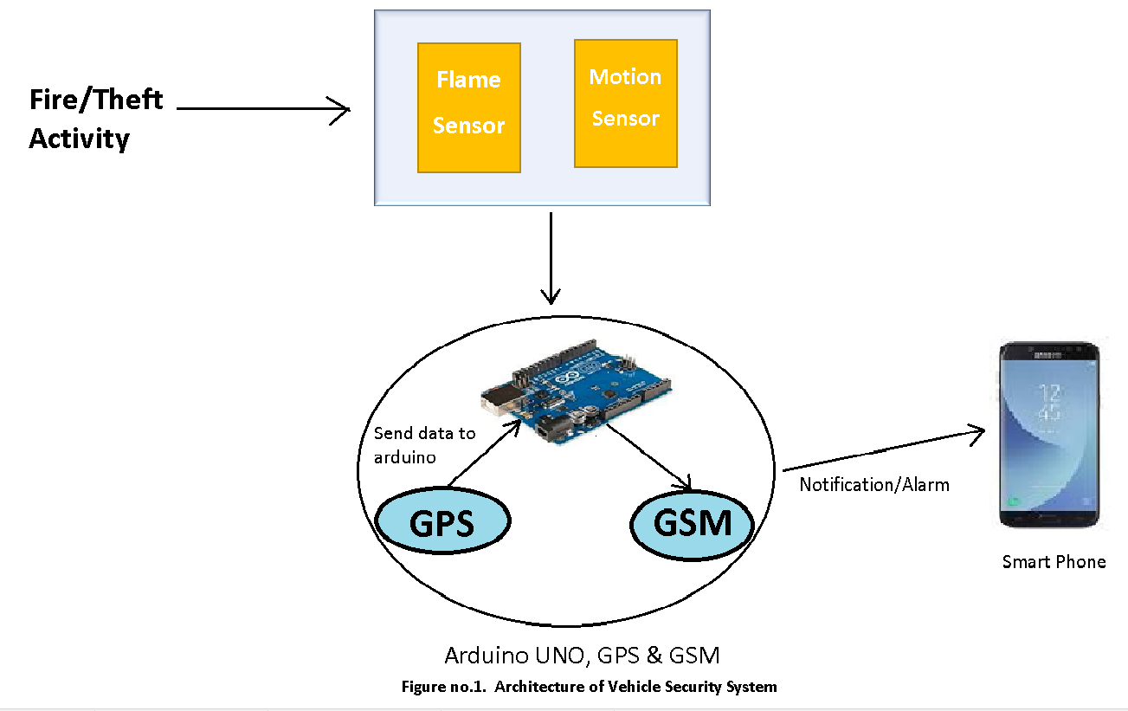

**Description:-**

This IOT based project aims to prevent vehicle from fire or from theft. Project requires Arduino, which can be connected to any moving vehicle. The system consist of Arduino, GPS, GSM, Sensors and Android phone. GPS is used for vehicle tracking. Fire detector sensor and smoke detector used to detect and respond to the presence of a flame or fire, allowing flame detection. An alert message will be received to the owner, when vehicle is at risk.

**4.2 Data Flow Diagram:**

**I) Level-0:-**

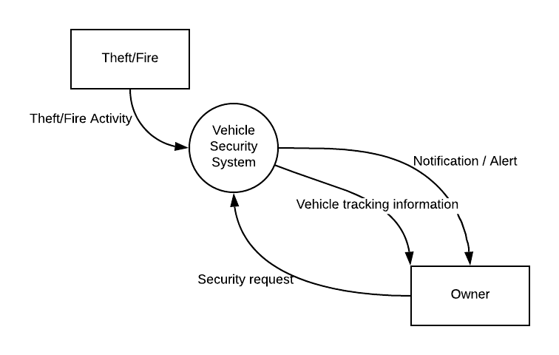

**Description:-**

The Level-0 diagram represents the entire system as a single bubble which is act as single process/system of vehicle security system. The rectangle represents the external classes from which input and output data indicted by incoming and outgoing arrows.

**2) Level-1:-**

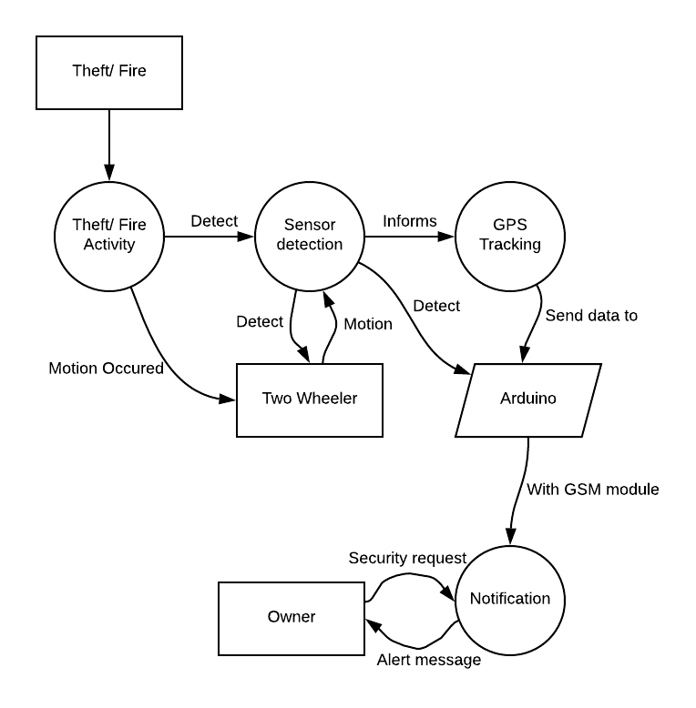

**Description:-**

The Level-1 diagram represent DFD into multiple bubbles or multiple processes. Each processes is decomposed into more detailed. Also represents input and output between different level DFD’s.

**3)Level- 2:-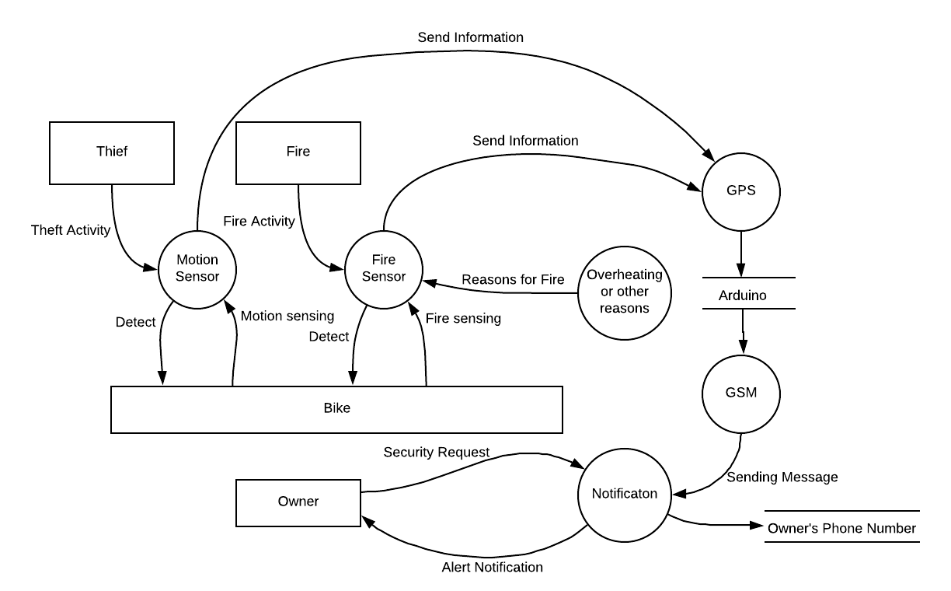 Description:-**

In this DFD level 2 diagram ,motion sensor, fire sensor, GPS ,GSM, notification, overheating other objects are the processes. Bike ,owner, thief and fire are external entities ,when theft activity occurs motion sensor detects the motion of bike and send information to GPS module then by using GSM module we send alert message to the owner. when fire activity occurs fire sensor detects the fire activity and by using GPS and GSM module it send alert message to the owner . after getting alert message owner turn off the vehicle

**4.3 UML Diagrams:**

**4.3.1 Use Case Diagram:**

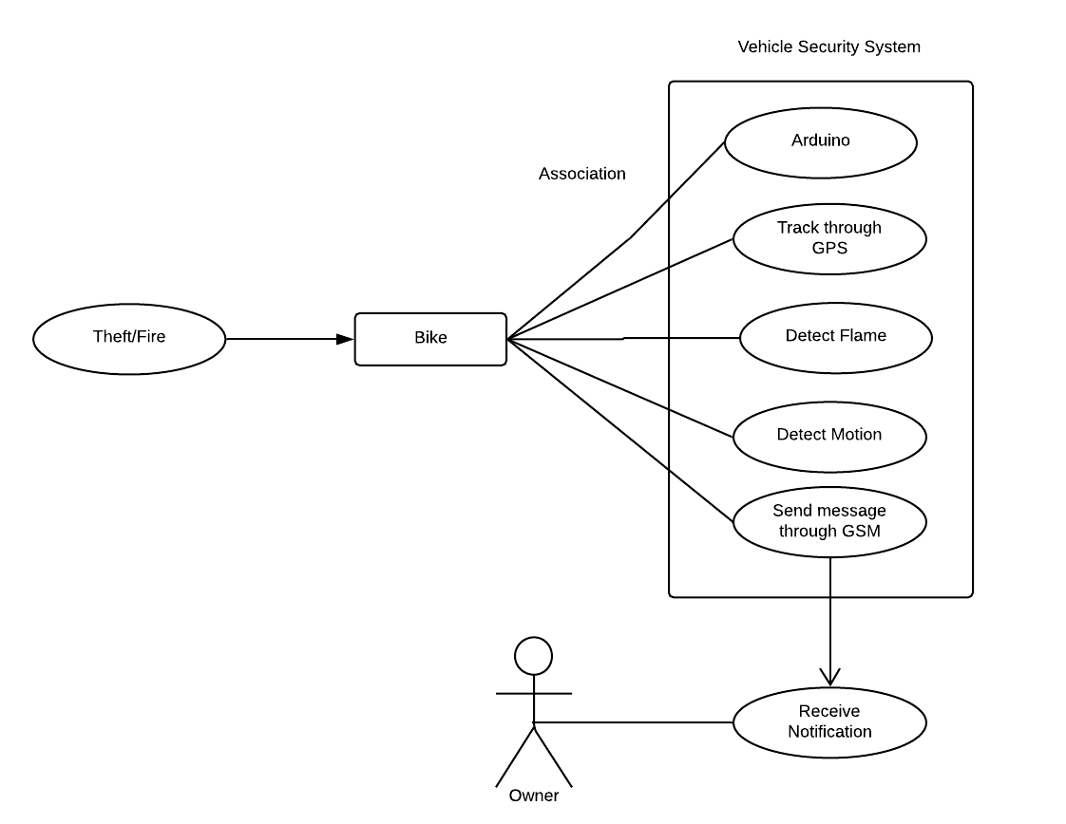

**Description:-**

In this Use Case Diagram, rectangle indicates Vehicle Security System. The Oval in the Use Case Diagram represents system function, which contains Arduino, GPS module, GSM module, Flame Sensor, Motion Sensor. Actor is owner of the system.

**4.3.2 Class Diagram:**

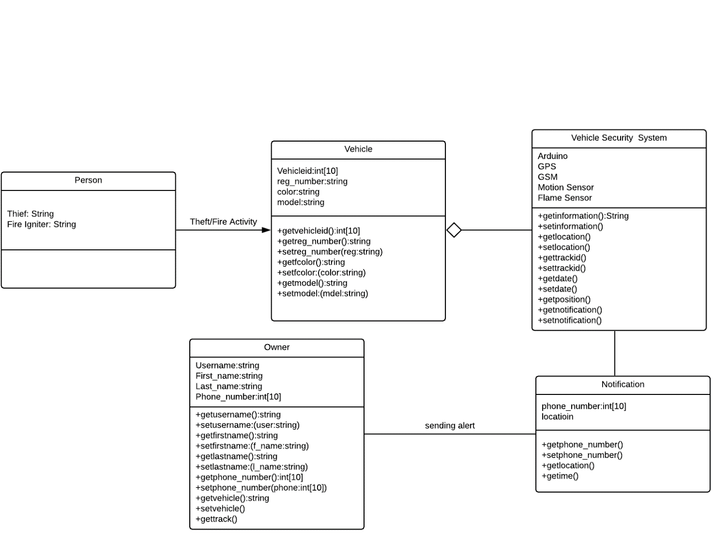

**Description:-**

In this above Class diagram, Person, Vehicle, Vehicle Security System, Owner, Notification are the class names. Thief, Fire Igniter are the attributes of class Person. Vehicle_id, reg_number, color, model are the attributes of Vehicle class. Owner has attributes username, First_name, last_name, phone_number. Phone_number,location are attributes of Notification.

**4.3.3 Sequence Diagram:**

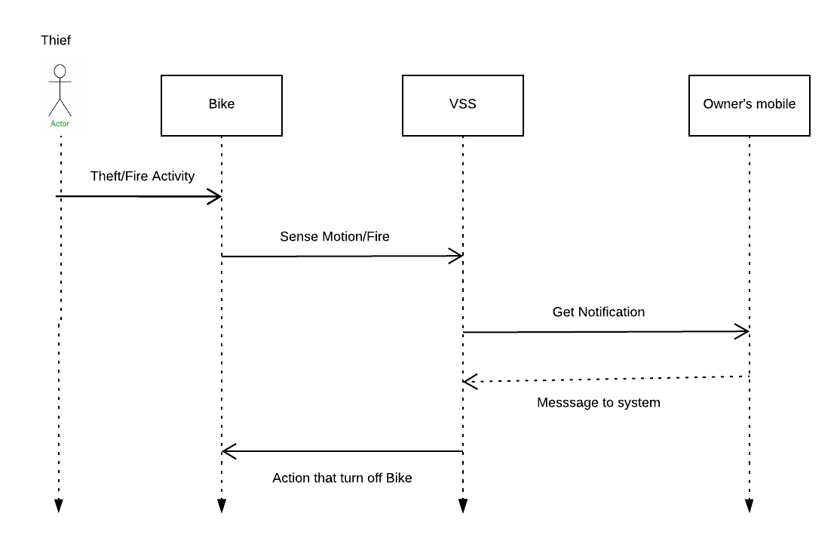

**Description:-**

Above diagram shows the dynamic diagram of vehicle security system, when theft activity or fire activity is happened then sensor sense the theft activity and send alert notification to the owner of the vehicle after getting alert message owner turn off the vehicle. Dash line represents the return message and solid line represents interaction between the objects.

**4.3.4 Collaboration Diagram:**

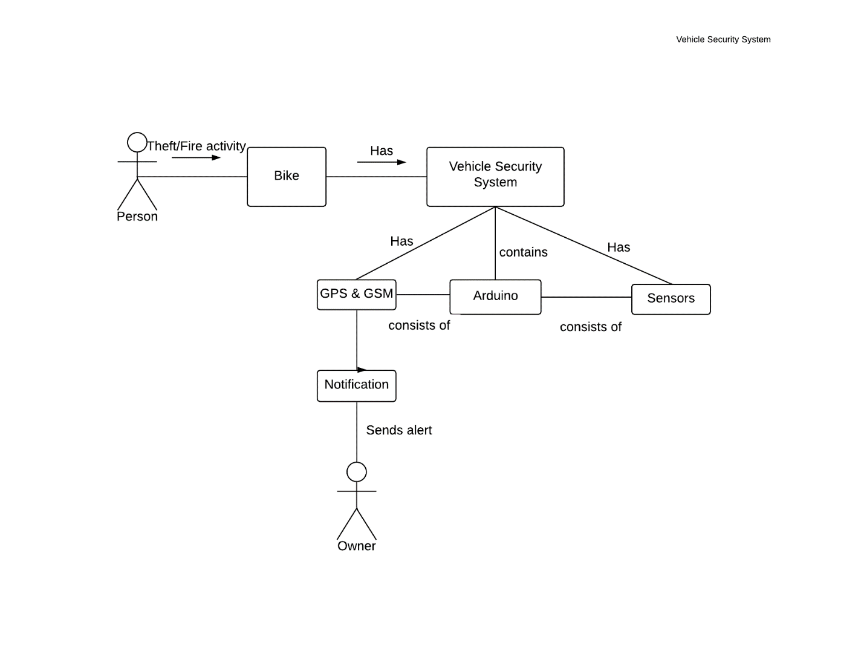 **Description:-**

Person represents Actor.Bike, Vehicle Security System, GPS, GSM, Arduino, Sensors, Notification are Objects.Line repesents Association.